**Lab Report No: 05**

**Name of the lab report: : Connecting (MySQL) with Linux.**

Name : Binodon

ID NO : IT-17046

**Objective:** This Lab is about the installation process of Mysql in Linux OS. And some execution of Query like insert,delete etc.

**Installation process of Mysql:**

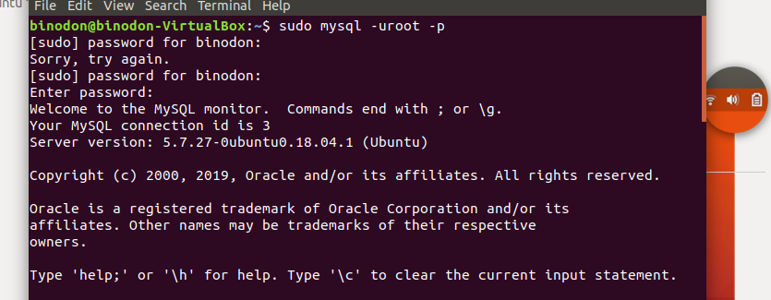

**Show the Databases:**

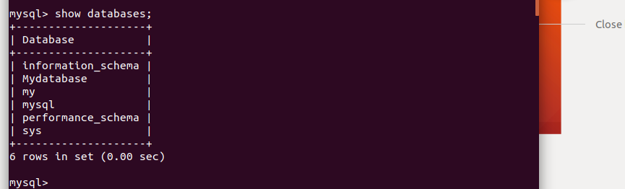

**Create New Database:**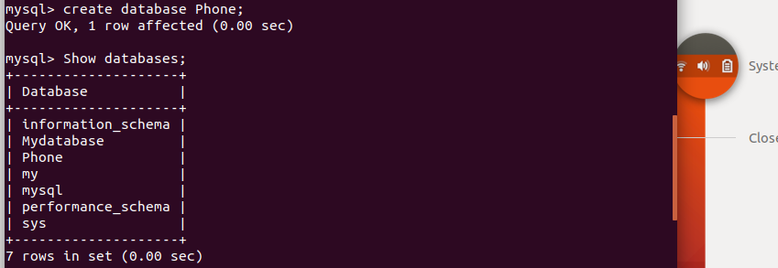

**Use the created database:**

C:\Users\ICT\Pictures\103.PNG

**Create A new table under the database:**



**Insert data in the Table:**

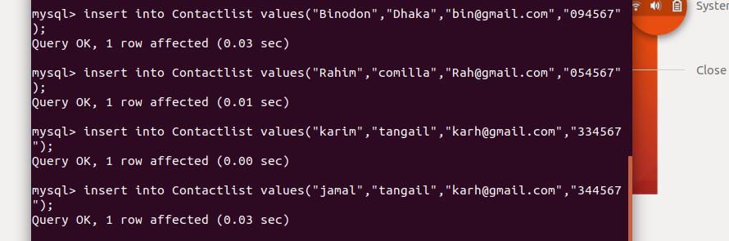

**Show the Table Data values:**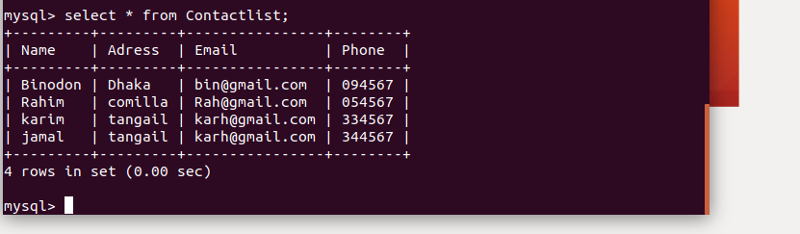

**Conclusion:**

In this lab we come to know about the installation process of mysql. And execute various query. To do this lab we didnot face any problem.